Procedure I ‐ Test Solution 1: Water

Trial 1
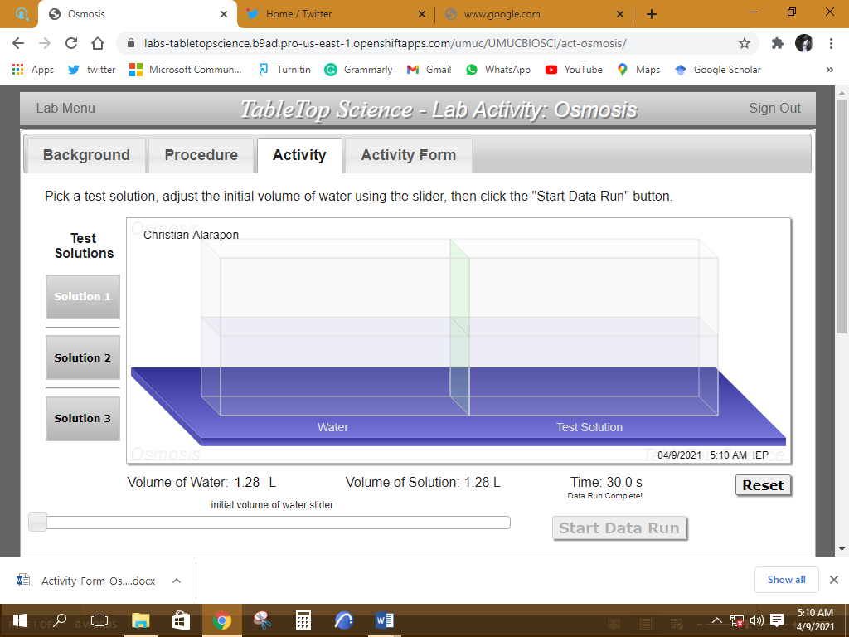

Trial 2

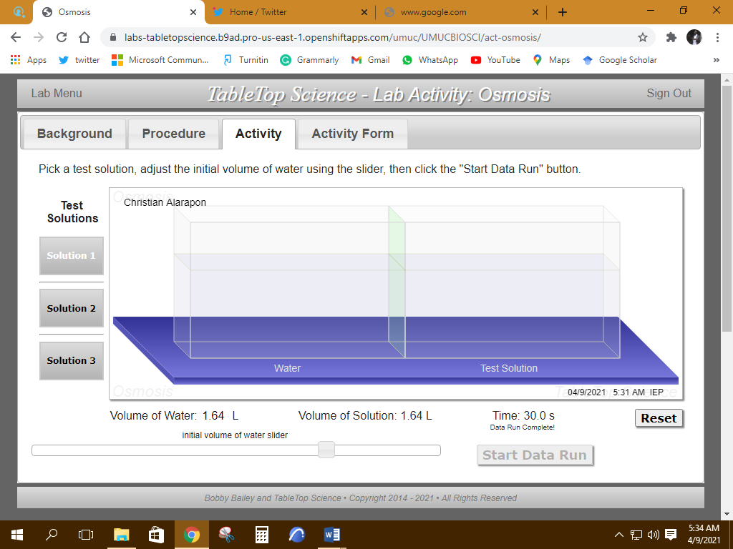

Procedure II ‐ Test Solution 2: Guanine solution (known concentration)
Trial 1
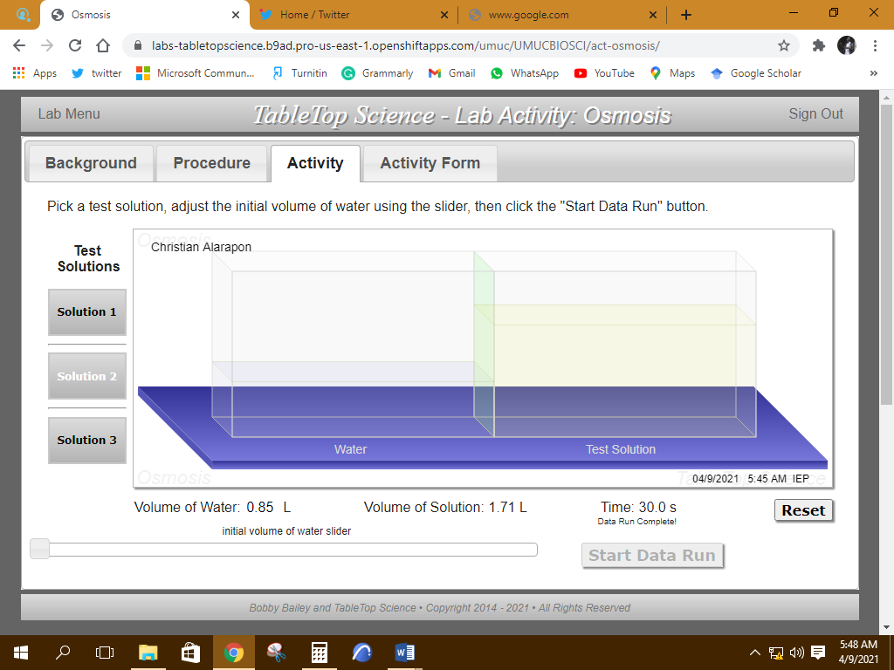

Trial 2
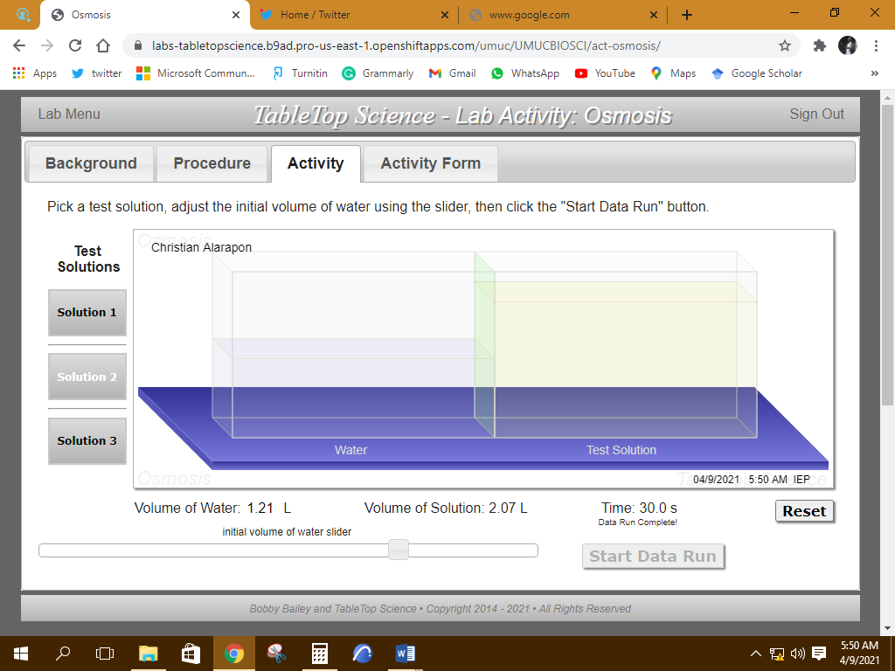

Procedure III ‐ Test Solution 3: Cytochrome C solution (unknown concentration)
Trial 1
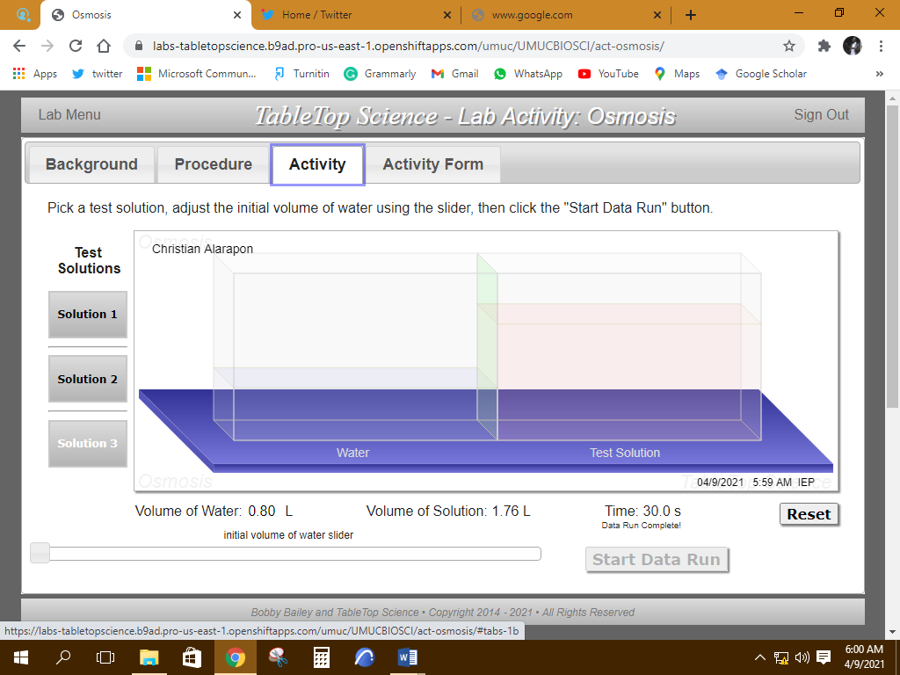

Trial 2
